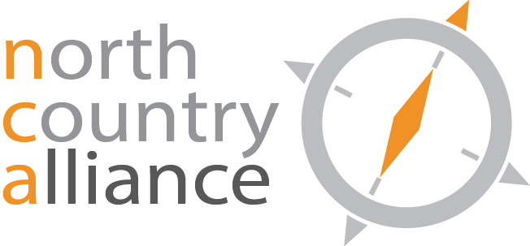

NCA Education and Outreach Committee
AGENDA
August 26, 2021
Zoom Meeting

- Update Agenda
- Strategic Planning/Next Steps

